
EAA Chapter 501
$2,000 Flight Training Scholarship

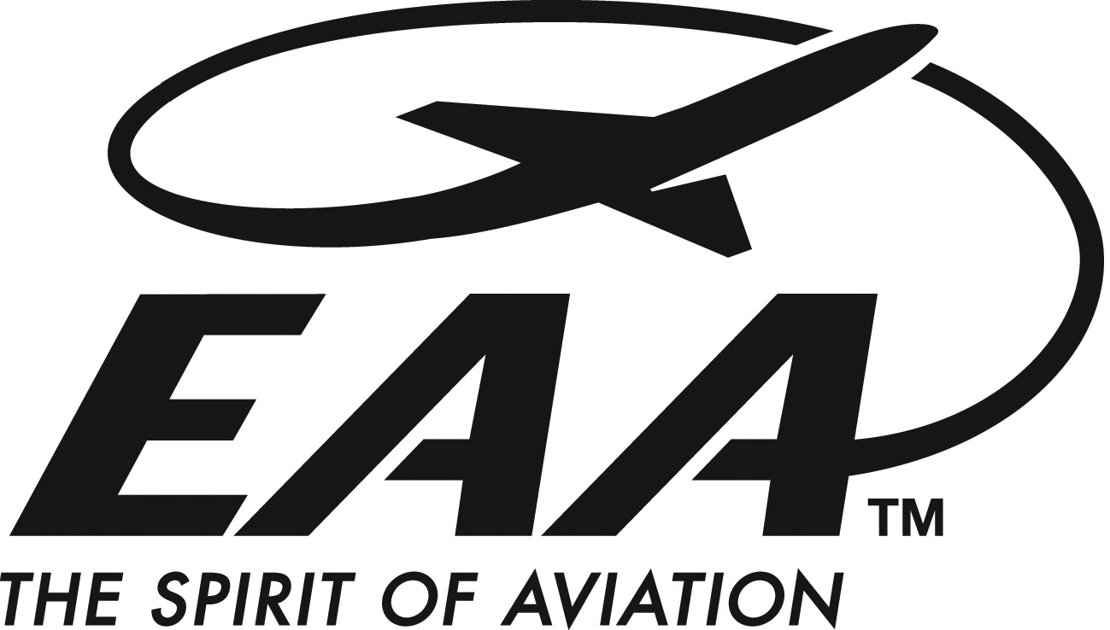

OVERVIEW:
- EAA Chapter 501 has a goal of promoting and furthering youth aviation education.
- To assist in meeting that goal, our Chapter will be awarding a flight training scholarship to an area high school student.
- Our goal is to provide the scholarship winner “jump start” funding for the first three to four hours of primary flight instruction.
- The scholarship will be in the amount of $2,000 paid directly to an approved flight school chosen by the scholarship winner.

ELIGIBILITY:
- Area high school students between the ages of 16-18.
- Previous completion of a Young Eagle Flight or Discovery Flight STRONGLY PREFERRED.
- Little or no previous formal flight instruction.
- Possession of an FAA Medical Certificate.

APPLICATION PROCESS:
- Complete an application (NOTE: Parent/Guardian must sign the application).
- Include a short (150-200 word) essay on why you want to learn to fly.
- Return the hard copy application, essay and copy of medical certificate to the Scholarship Coordinator at the address listed on the application.
- Participate in a short interview with a Chapter 501 representative.

APPLICATION DEADLINE:
- Applications (hard copy) must be received no later than FRIDAY OCTOBER 16TH, 2026.

An application with detailed instructions can be requested from:
scholarship@eaa501.org

